PalestineRemembered.com

* The Home Of All Ethnically Cleansed Palestinians
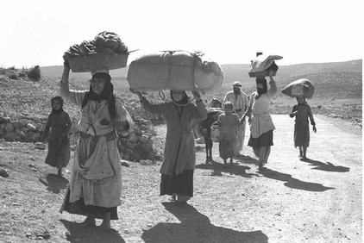
Ethnically cleansed Palestinians fleeing their homes to Lebanon, Oct. 1948

PalestineRemembered.com contains the most comprehensive online database about the 450 ethnically cleansed and destroyed Palestinian towns. A wealth of information has been researched and presented for each listed town, such as rare photos before and after destruction, dates of occupation and ethnic cleansing, land ownership size for Palestinians and Jews, population, number of houses, schools, religious institutions, shrines, the names of the usurping Israeli settlements, maps, archeological sites, the status of each town today, and more.

Using state of the art technologies, PalestineRemembered.com empowers Palestinians around the globe to upload to each listed town’s homepage pictures, movies, stories and memories, URL links, responding to other members on message boards, guest book entries, directory service entries, and more. At the website, Palestine is being resurrected in cyberspace, where Palestinians can recreate their lost sense of community again since al-Nakba.

Take the time to educate yourself, your family, and your friends about the core issues of the Palestinian-Israeli conflict. The Palestinians side of the story has been purposely distorted in the Western media, and we hope that your participation will draw the much needed attention to the plight of the Palestinian refugees, the first permanently dispossessed people of the 20th century.

____________________________________________________________________________________________
* PalestineRemembered.com is a none profit organization dedicated to preserving the collective experiences of the 5.9 million dispossessed Palestinian refugees.

